|  |  |
| --- | --- |
| **Performing for the MS Support Group at Nevins Memorial Library, Methuen** |  |

*Hi Kasia,*

*Thank you again for the lovely musical numbers you and your children performed for our group.*

*We all enjoyed it very much, and look forward to your return visit.*

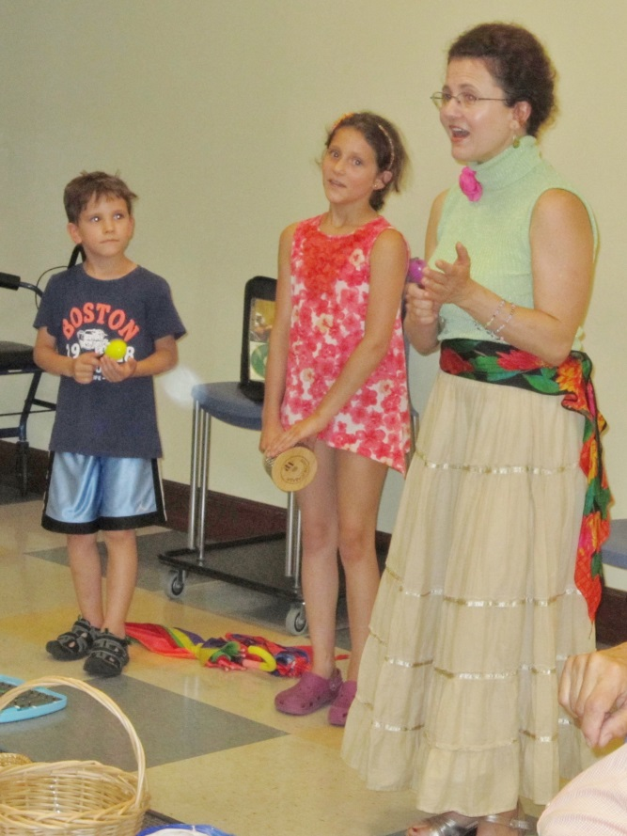

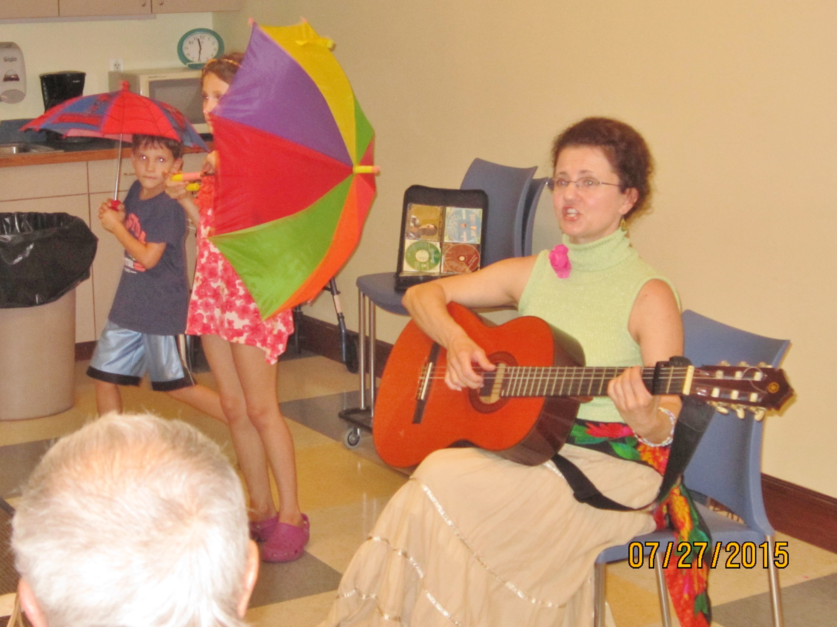

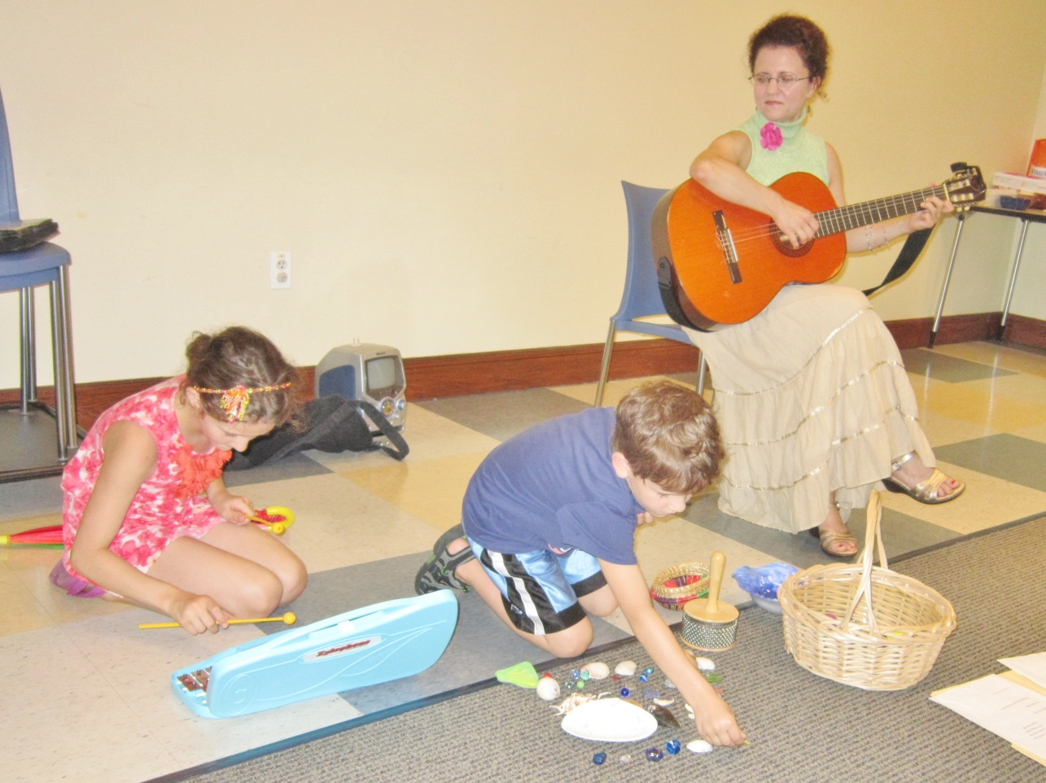

*We are all amazed at how well your children accompany you. They are a true treasure.*

*Hope you enjoy the attached photos. More will follow.*

*Martha & Joe Morello*[*martha-joe@comcast.net*](mailto:martha-joe@comcast.net)

*Sept 5, 2015*